Compendium of Common earthlings



Reprinted from the:

A.A.A.A.A

T.R.A.V.E.L.E.R.S

I.N.T.E.R.-.G.A.L.A.C.T.I.C

P.O.C.K.E.T G.U.I.D.E B.O.O.K

From page
8769544323 to 876954329

EARTH/EARTHLINGS

WARNING

ALL SHIPS ARE RECOMMENDED TO TAKE EXTREME CAUTION WHEN TRAVELLING NEAR EARTH.

LANDING HERE IS STRICTLY FORBIDDEN!

The inhabitants of this planet are widely known to be the most unpredictable creatures in the sector. Predominant among the earthlings are the humans, known for their destructive nature as well as for their tendency to take themselves far too seriously. Also worthy of note is the human’s general lack of a healthy party-down attitude, and their almost non existent sense of Funk.

Following is a listing of the various earthlings you may encounter should you ever land on this planet (Even though, of course, it’s forbidden, so obviously you wouldn’t, but if maybe you crashed or something, or maybe you decided to land there anyway, which of course you wouldn’t, but if you did…).

1 CRAZED SHOPPER (Spenditallinadae)

This creature is actually a relatively minimal threat. She’s in a constant state of “buying frenzy” and will usually be only marginally aware of your presence. The distracted, or crazed state of mind is often aggravated even further by the presence of a screaming young human, usually propelled by the Shopper in a metal conveyance called a shopping basket.

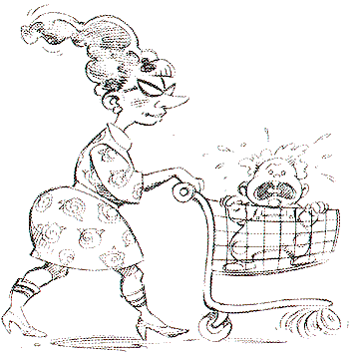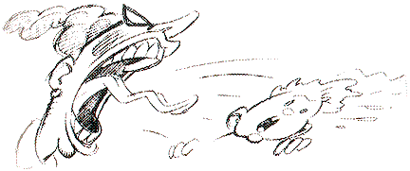

2 WISEMAN (Carrotus Smartius)

The Wiseman, or carrotman as he is also called, is one of the few non-hostile natives of planet earth. For a couple of bucks this creature will identify the content of an unidentified present.
Many who are not so wise have asked the question “Why the carrot suit?” He has never actually answered this question, but since he is the Wiseman, it is assumed that he has his reasons
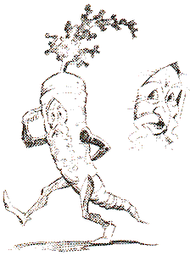

3 THE WAHINI (Hawaiinus Bootius Shakium)

Wahines are young Hawaiian maidens with a strange and compelling charm. Wearing only skirts made of grass, and leis of flowers, these Earth creatures spend all their time doing the hula. Anyone who gets close to them will find joining them in this strange alien dance all but irresistible. In fact, the closer one gets to a Wahini, the harder it is to resist dancing. As pleasant asz this may seem, it can be quite annoying when one is being pursued by a more hostile Earthling.

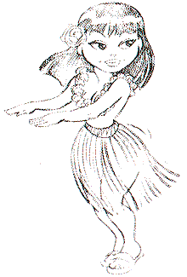
4 INSANE DENTIST (Painus Maximus)

This earth creature is particularly sneaky. Under the guise of fixing your teeth, he delights in inflicting as much pain as humanly possible. After drilling you with his oversized workman’s drill, he will usually stop to cackle and gloat. This can often be your chance to get away.



5 CUPID (Cupidus Stupidus)

This adorable little cherub, also known as the Cupid, Or Baby of love, has the annoying habit of singing of key and of shooting nasty little arrows. If you should happen to get hit with one of these arrows you will fall immediately in love. Be warned, falling in love is not all its cracked up to be. If you do touch one of these charming cherubim by using Icarus wings, Spring shoes or Super Hi-tops, it will fall out of the sky and pop.

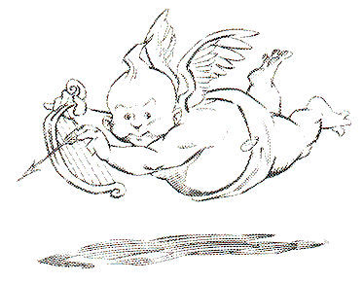

6 HAMSTER IN A ROLLY-BALL
(Rodentia Nottoosmartium)

These creatures are probably the least intelligent of all the Earthlings. Trapped inside of large clear plastic balls, these giant hamsters run continuously, attempting to get away from the plastic ball.
Funkotron scientists have no theories at present to explain how they got into these balls, and the question of how they eat or reproduce is a source of major controversy. Since hamsters do not move very fast, simply walk away from them

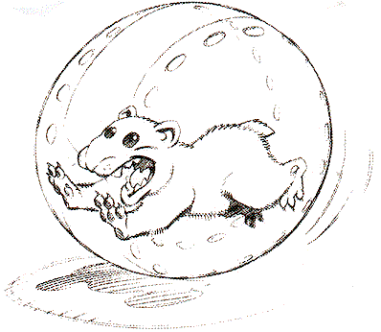
7 BOGEY MAN (Pygmyus Scaremtadeathium)

The bogey Man is one of the most dangerous of all earth creatures. When not moving, it’s completely invisible. When it is moving, it’s only a tippytoeing shadow. The bogey Man lives for the pleasure of sneaking up on unsuspecting victims and shouting the words “Bogey Boogey Bogey.”

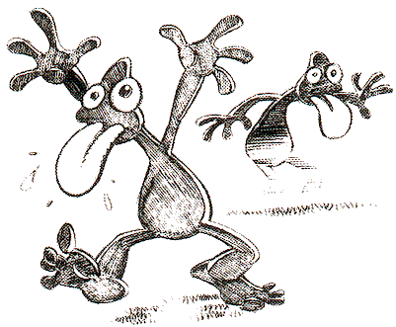

8 NEDHERD (Geekus Dorkia)

While human are generally accepted as being the most insane and bothersome of all the earth creatures, Nerdherds are a subspecies of humans which are even worse in these respects. Unlike other individual creatures, the Nerdherds is actually a collection of creatures which are bound together by a powerfull force referred to by Funkotron scientist Dr. Funkerman as “the Geek Field” or the “Extradimensional Insecurity Effect”.

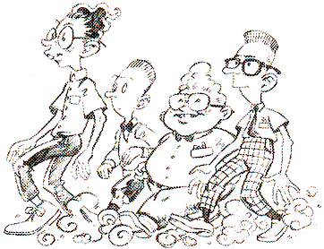

9 MOLE (Diggus Theifius Yawannakillum)

One of the quickest moving of the Earth creatures, this little rodent will burrow right underneath you and steals some of your presents. Then it will leave you alone untli you have left the area and come back, or until you pick up a new present

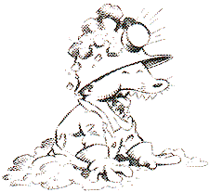

10 SANTA (Ho Ho Hoium)

Funkotron scientists generally believe this is the earthling responsible for all the presents lying around. Occasionaly the odd traveller has reported running across Santa himself. He is usually spotted rummaging through his sack of presents.
According to these reports, one may sneak up on Santa and grab a goody or two. Of course, by taking presents from Santa one may wish to consider that one is depriving some poor needy child of a toy on Christmas morning. On the other hand, the phrase “tough luck, finders keepers” also comes to mind.

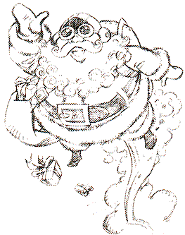

11 ANGRY BEES (Buzzius Stingium)

Nobody knows exactly why these tiny Earthlings are so angry, but it is generally a good idea to keep away from them. While all bees look the same, there are actually two types of bees: normal bees and deadly bees.
Normal bees are easier to get rid of due to memory lapses. Deadly bees, on the other hand, are much more single-minded.

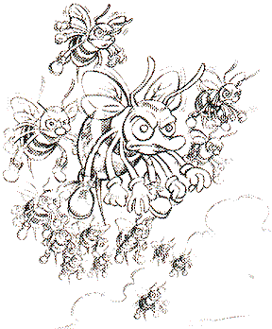

12 WIZARDS (Prestidigium Healum Ferabuckium)

These Earthlings are perhaps the friendliest creatures. They can generally be found wandering slowly about, pondering weighty prestidigitative matters of great signifiance. Wizards will also perform healings for a buck. To get healed, simply stop moving when next to the wizard. Then say “Yup” when he asks you for a buck.
One of the great mysteries that continues to baffle Funkotron scientists centers around the source of the “Hallelujah!” that is heard at the time of healing.

13 MAILBOX MONSTER
(Mailboxium Donttrustium)

Most earthling humans are completely unaware of the danger they are in every time they mail a letter. This is due to the nefarious mailbox monster. It disguises himself as a mailbox and sits and waits for unsuspecting victims to walk up to it to mail a letter.
If one is patient, one can always tell a mailbox from a mailbox monster by waiting and watching it. Sooner or later, a monster will reveal itself by blinking its eyes. Other ways to identify a monster include making it and, of course, walking straight up to it and hoping for the best.
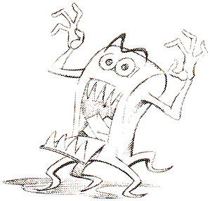

14 LIL DEVIL (Devilus Pokium)
This earth creature has been named the Lil Devil. Some scholars believe it is due to the fact that it is small and red, and has horns, a tail and a pitchfork. Others believe it is only a colloquial reference – referring to the fact that this creature is particularly mischievous and annoying.

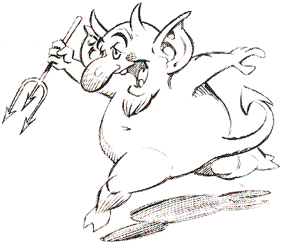
15 SHARK (Fishius Notsoniceum)

What can one say about the shark? Big teeth. That is one can say about the shark. The most effective defense against this water creature is to stay out of the water. When this is unavoidable, the other best defense is to swim like crazy.

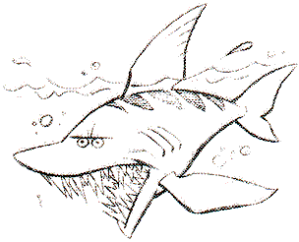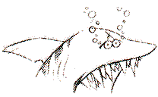

16 TORNADO (Spinnus Makemsickium)

Technically speaking, the tornado is not so much a creature as it is a phenomenon. In spite of this, many visitors on planet Earth have claimed that tornadoes seems to be intelligent, and actually chase visitors in an attempt to sweep them up.
While Funkotron scientists are skeptical, we feel it’ s safest to issue a warning nonetheless. Reports indicate that it is possible to avoid being caught by the tornadoes by swerving out of the way at the last minute

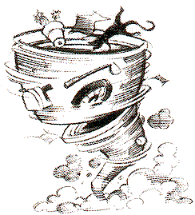

17 FAT MAN & MOWER
(Americanus Suberbium)

Look out for this earthling. One of the most dangerous of all earthlings, it is believed to be representative of the majority of male humans living in a region called “Middle America.”
This creatur spends large amounts of time walking back and force in front of its place of dwelling, pushing a loud destructive machine known as a lawn mower. It is believed that this territorial behavior is an attempt by the males of this species to intimidate other males. As a sign of dominance, many of this males sport impressive stomachs. These are thought to attract females of the species.

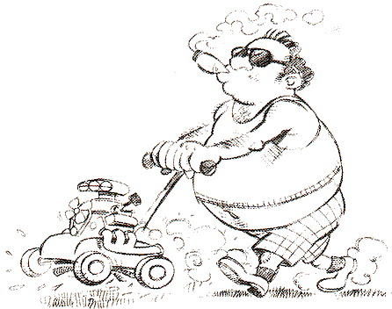
18 OPERA SINGER (Fattus Singus Irritatus)

The opera singer is actually a helpful earthling, even though her help is largely unintentional. In her never-ending desire to find herself an audience, she will follow you around and sing for three bucks.
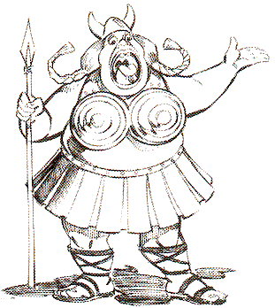

WARNING! After paying her, quickly cover your ears. It has yet to be determined how much eardrum damage could be caused by listening, but her singing is clearly powerful enough to pop all other Earthlings in the immediate area. This can be quite useful when surrounded by numerous hostile natives. If one happens to be wealthy, this singer can actually follow along for awhile and act as a bodyguard

19 CHICKENS WITH MORTARS
(Cluckus Artillarus)

These earthlings are only slightly less intelligent than the human of planer Earth, and unfortunately, they are equally as aggressive. These roving bands of poultry wander the countryside looking for opportunities to fire their tomato-launching mortars. Whenever they do this they become very excited, and cluck uncontrollably
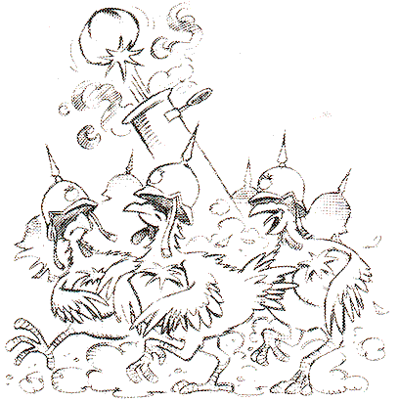

20 PHANTOM ICE CREAM TRUCK
(Driverus Insanicus Ghostium)

Quite possibly the most feared of all earthlings. Many unsuspecting victims have been lured out of the safety of their homes by the sweet tinkling sound of music, only to see a ghostly Ice Cream truck bearing down on them from out of the mist.
No one really knows the story behind this spectre of frozen confections, but it is assumed to be a tragic and awe-inspiring one.

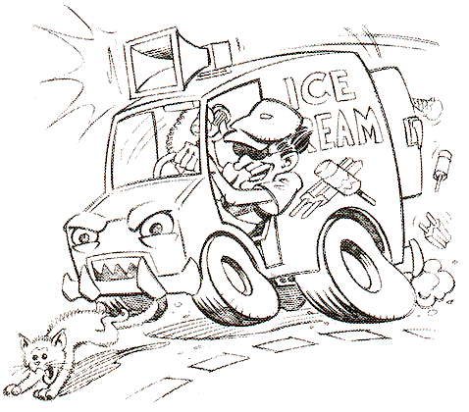

The Funkotronian Inter-Galactic Academy of Spatial Travels endorses no responsibility for unexpected comportment of any creature on Earth.

Legal 1990
Printed with agreement of the
Funkotronian Inter-Galactic Academy of Spatial Travel

